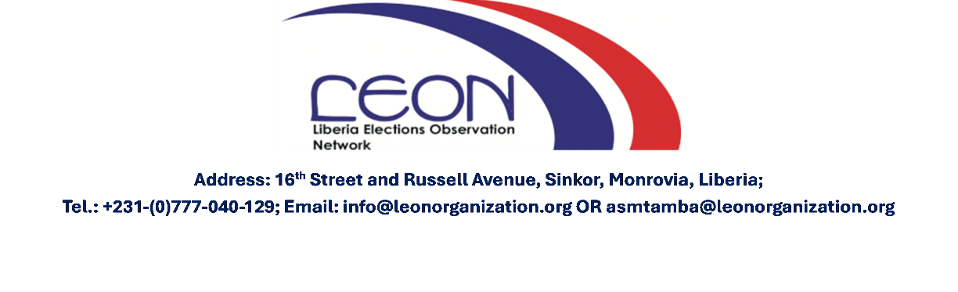

LIBERIA ELECTION OBSERVATION NETWORK
LEON

GRAND GEDEH COUNTY
DISTRICT ONE (1) PROFILE
REPRESENTATIVE CONSTITUENCY

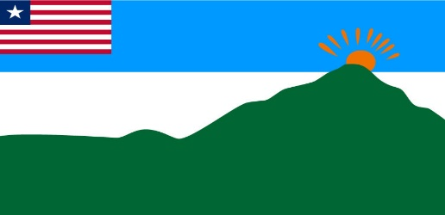

FLAG OF GRAND GEDEH COUNTY

MARCH 2024

Table of Contents
OVERVIEW OF GRAND GEDEH COUNTY 1
GRAND GEDEH ELECTORAL DISTRICT ONE 1
POPULATION DEMOGRAPHY 2
BACKGROUND TO THE 2024 BY-ELECTION 2
2024 BY-ELECTION – NAME OF CANDIDATES IN DISTRICT ONE (1) 2
2023 ELECTION RESULTS 3
NOMINATION AND CONTESTING CANDIDATES 4
POLITICAL ENVIRONMENT AND CAMPAIGN 4
2021 ELECTORAL DISTRICT ONE (1) Result 4
2017 ELECTORAL DISTRICT ONE (1) 5
ELECTORAL DISTRICT ONE 2011 6
GRAND GEDEH FREQUENTLY ASKED QUESTIONS (FAQs) 8

OVERVIEW OF GRAND GEDEH COUNTY
Grand Gedeh is one of the few leeward counties created in the 1964. Grand Gedeh was formerly known as the Eastern Province under the 1847 Constitution of Liberia. Its original capital was Tchien, now known as Zwedru.
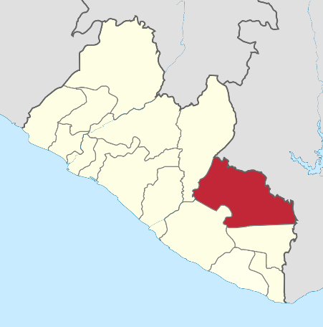
The then Eastern Province comprised two districts, Webbo (now part of River Gee County) and Tchien. Today Grand Gedeh County is subdivided into two statutory districts, eight administrative districts, 16 Chiefdoms, 32 Clans, three Cities, and 236 towns.
Grand Gedeh County, Liberia (Source: Wikipedia, 2024)
The County is noted for its rich iron ore reserves and vast forest, which are depicted in the county flag. The county flag has four colors: blue, white, green, and orange. The green represents the rich forest and highlands, while the white and blue depict peace and unity. The sun in the background painted orange represents the new era of development. The superintendent of Grand Gedeh is Peter L. Solo.
Grand Gedeh is in southeastern Liberia, bounded on the north by north-west by Nimba, on the north-west by the east by the Cavalla River, forming the boundary with Cote d’Ivoire, on the south by River Gee County, and on the south-west by Sinoe County. The total land area of Grand Gedeh County is 10,276 km, which is about 9.22% of the total land area of Liberia.

GRAND GEDEH ELECTORAL DISTRICT ONE
Grand Gedeh Electoral District One is bordered on the East by Upper Gorbo Cavalla, on the North by Gleplay, on the South by Tchien and on the Southwest by Beezon.

Figure 2: Map of Electoral District One (1)
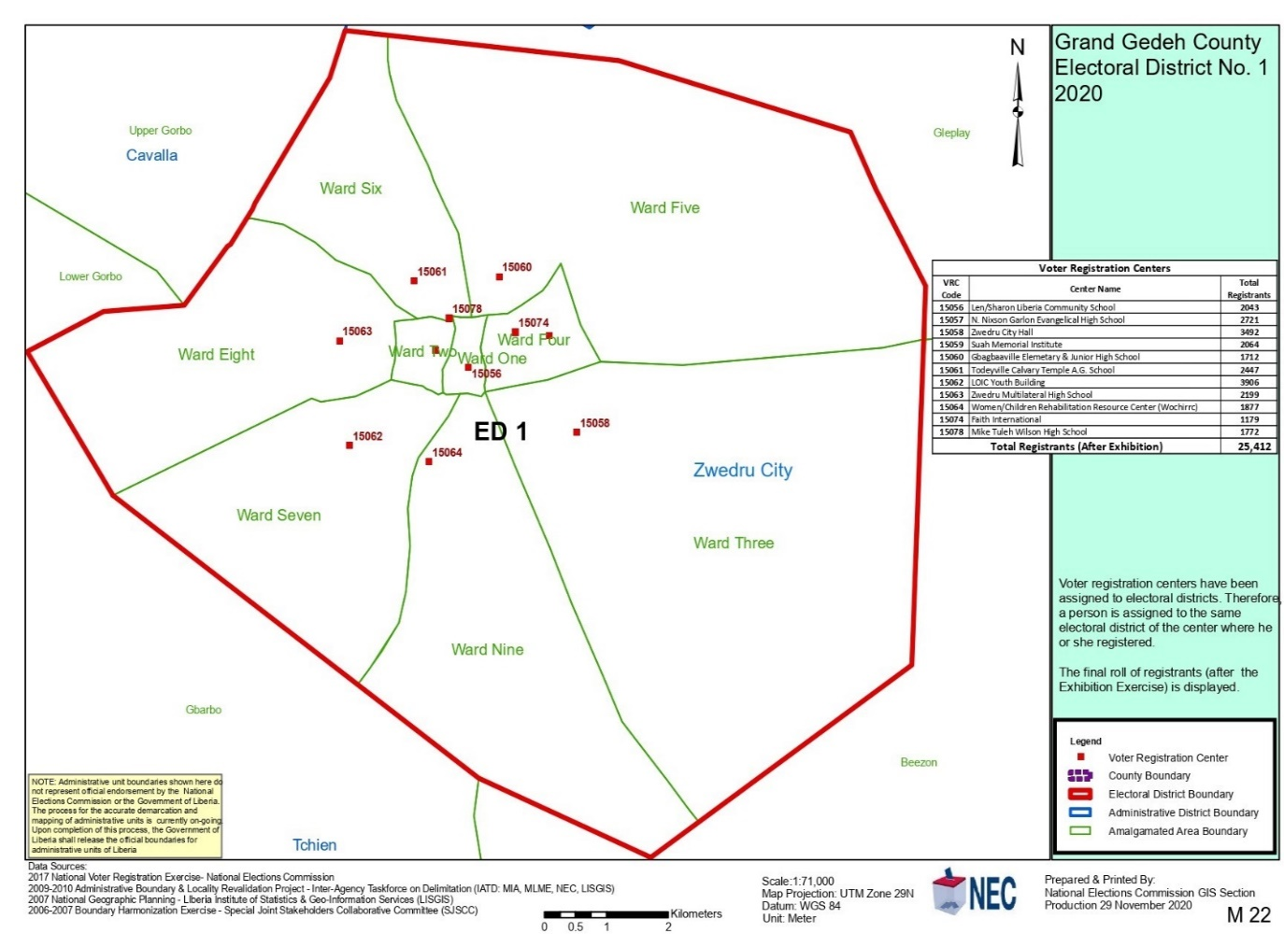

POPULATION DEMOGRAPHY
According to the Nation Election Commission BVR report, the Registered voters in Electoral District one is 20,443 comprising of 10,105 males and 10,297 females.

BACKGROUND TO THE 2024 BY-ELECTION
On October 10, 2023, Liberia headed to the polls to elect a representative who will serve a six-year term. Hon Erol Madison Gwion was elected. With respect to details and close with the authority to conduct the By-Election, On February 2024, the NEC received a communication “by directive of the Honorable House of Representatives”, informing the Commission that “the passing of Hon. Erol Madison Gwion, Representative-elect, District #1, Grand Gedeh County has created a vacancy in the House of Representatives”. District #1, Grand Gedeh County, there are 20,407 registered voters and 11 precincts comprising 46 polling places.

2024 BY-ELECTION – NAME OF CANDIDATES IN DISTRICT ONE (1)
S/NO. | LAST NAME | FIRST NAME | MIDDLE NAME | GENDER | PARTY
1 | Beh | Amelia | Polodee | Female | People's Unification Party (PUP)
2 | Boley | Watchen | Ophelia | Female | Liberia Transformation Party (LTP)
3 | Charafeddine | Camile | V | Female | Unity Party (UP)
4 | Clarke | Justice | Randall | Male | New Liberia Party (NLP)
5 | Cooper II | Cyrus | S. | Male | Vision for Liberia Transformation (VOLT)
6 | Dorbor | Elijah | Poneyon | Male | All Liberian Solidarity Party (ALSOP)
7 | Dukuly | Ansu |  | Male | National Development Party (NDP)
8 | Gbaba | Nathaniel | Chen | Male | Reformer National Congress (RNC)
9 | Gwion | Moniayoung | Jerry | Male | Democratic National Allegiance (DNA)
10 | Johnson | Gabriel | Papee | Male | Liberia People's Party (LPP)
11 | Johnson Jr. | Roosevert |  | Male | Liberia National Union (LINU)
12 | Kannah | Isaac | Nyaneyon | Male | Liberian Restoration Party (LRP)
13 | Quiyea | Jeziah | M | Female | Freighters
14 | Sokan Jr | Jeremiah | Garwo | Male | Independent
15 | Williams | Sampson | B | Male | African Liberation League (ALL)

PREVIOUS ELECTIONS IN DISTRICT ONE
2023 ELECTION
In the 2023 election, there were 20407 registered voters. The total turnout was 14,768 (72.37%). There were six contestants. Two females and four males. Mr. Gwion Sr. Erol Madison from the Liberia Restoration Party (CDC) won the district with 8,651 (61.39%) votes. followed by Watchen Boley (LTP) with 2,295 (16.29%) votes took second place, and Mr. Dukuly Ansu from the Collaborating Political Parties (CPP) with 1748 (12.4%) took third place.
Figure 3: Top three candidates 2023 election

Source NEC

2023 ELECTION RESULTS
No. | Names | Party | Votes | Gender | Percentage of votes received
1 | Gwion, SR. Erol M. | CDC | 8,651 | M | 61.39%
2 | Boley, Watchen O | LTP | 2,295 | F | 16.29%
3 | Dukuly, Ansu | CPP | 1,748 | M | 12.4%
4 | Kannah, Isaac N | LRP | 9,424 | 588 | 4.17%
5 | Diahn, Diahngee A. | LPP | 446 | M | 3.16%
6 | Quiyea, Jeziah M. | PUP | 364 | F | 2.58%
Source NEC

NOMINATION AND CONTESTING CANDIDATES
S/No. | Last Name | First Name | Middle Name | Gender | Party
1 | Ansu | Dukuly | - | M | Collaborating Political Parties
2 | Erol | Gwion | M | M | Congress For Democratic Change
3 | Diahngee | Daihn | A | M | Liberia People Party
4 | Isaac | Kanneh | H | M | Liberia Restoration Party
5 | Watchen | Boley | O | M | Liberia Transformation Party
6 | Jeziah | Quiyea | M | M | People’s Unification Party
Source NEC

POLITICAL ENVIRONMENT AND CAMPAIGN
On April 4, 2023, the Farmington River Declaration 2023 was signed by 27 leaders of 31 political Parties, and the United Nations (UN) and Economic Community of West African States (ECOWAS) signed the document as witnesses. Liberia’s National Election Commissions, ECOWAS, and UN organized the auspices of the signing ceremony in Margibi. Generally, there were peaceful campaign activities during the campaign and on election day.

2021 ELECTORAL DISTRICT ONE (1) Result
In the 2021 by-election district one registered voters were 25,412 of the precincts eleven turned out voters were 7,352 (28.93%) of fifty sex Polling Places. There were six contents all were Males (100.00%). Mr. Gwion Sr. Erol Madison from the Liberia Restoration Party (LRP) won the district with 3,404 (47.58%) votes, followed by Mr. Sokan Sr. Jeremiah Garwo from the Coalition for Democratic Change (CDC) with 2,698 (37.8%) votes took second place, and Mr. Dukuly Ansu from the Collaborating Political Parties (CPP) with 494 (6.91%) took third place.

Figure 4: TOP THREE CANDIDATES 2021 BY-ELECTION RESULTS

Source NEC

TABLE 2. NAME OF CONTESTING CANDIDATES AND RESULTS 2021
CANDIDATES | VOTES | VOTER PERCENTAGE
DUKULY, ANSU (CPP) | 494 | 6.91%
GWION, SR., EROL MADISON (LRP) | 3,404 | 47.58%
SAYDEE, FESTER JARBAH (PUP) | 178 | 2.49%
SOHN, SEWARD (LINU) | 199 | 2.78%
SOKAN, SR, JEREMIAH GARWO (CDC) | 2,698 | 37.71%
YAH, GEORGE NYAN (RA) | 181 | 2.53%
Source NEC

2017 ELECTORAL DISTRICT ONE (1)
In the 2017 election District One had 23,355 registered voters in eleven (11) Precincts voter turnout was 15,872 (67.96%). There were (11) Contestants one female (9.0%) and ten (90.9%) males. Mr. Pennue Zoe Emmanuel an independent (IND) candidate won the district with 8,499 (55.74%) votes, followed by Mr. Sokan Jeremiah Garwo an Independent (IND) candidate with 3,166 (20.76%) votes, and Mr. Charafeddine V. Camille from the Liberty Party (LP) with 1,091 (7.16%) votes.

Figure 5: TOP CANDIDATES 2017

Source NEC

TABLE 2. NAME OF CONTESTING CANDIDATES AND RESULTS 2017
CANDIDATES | VOTES | VOTER PERCENTAGE
BAILEY, Christopher Beh (UP) | 263 | 1.72%
BARH, Lawson V. (ALP) | 298 | 1.95%
CHARAFEDDINE, Camille V. (LP) | 1,091 | 7.16%
CLARKE, Justice R. (VOLT) | 68 | 0.45%
COOPER II, Cyrus S. (UPP) | 153 | 1.00%
DORBOR, Elijah P. (MOVEE) | 423 | 2.77%
GWION, SR., Erol Madison (CDC) | 1,003 | 6.58%
KABA, Sleekey Barbah (ANC) | 117 | 0.77%
PENNUE, Zoe Emmanuel (IND) | 8,499 | 55.74%
SAYDEE, Randolph Yonkpao (LTP) | 167 | 1.10%
SOKAN, Jeremiah Garwo (IND) | 3,166 | 20.76%
Source NEC

ELECTORAL DISTRICT ONE (1) 2011
The registered voters in 2011 were 16,127. Turned out were 10,834 (67.18%) at 70 polling places. Mr. Pennue Zoe Emmanuel of LP won with 5,851 (57.07%) votes, followed by Mr. Charafeddine V. Camille with 3,057 (29.82) votes and Mr. Funnebo H. Nyounpao D. with 873 (8.52%) votes in third place.

Figure 6: Top Three Candidates 2011

Source NEC

TABLE 2. NAME OF CONTESTING CANDIDATES AND RESULTS 2011
CANDIDATES | VOTES | VOTER PERCENTAGE
CHARAFEDDINE, Camille Vlendy (CDC) | 3,057 | 29.82%
FUNNEBO, H. Nyounkpao D. (UP) | 873 | 8.52%
GWION, SR., Erol Madison (LP) | 471 | 4.59%
PENNUE, Zoe Emmanuel (Independent) | 5,851 | 57.07%
Source NEC

GRAND GEDEH FREQUENTLY ASKED QUESTIONS (FAQs)

Election Snapshot:
By-Election day: April 23, 2024
Registered voters:20407
Number Precincts:11
Number of polling stations: 46
Social/physical distancing:
Seat to be contested for 1
Number of aspirants/applicants:
Donation limit and campaign expenditure:
Facts about the 2024 By-election
February 2, 2024, the NEC received a communication “by directive of the Honorable House of Representatives informing the Commission that “the passing of Hon. Erol Madison Gwion, Representative-elect, District #1, Grand Gedeh County has created a vacancy in the House of Representatives”. In a communication, the Legislature emphasized that the letter constituted the sufficient authority of the Commission to conduct a by-election. Additionally, the Key Dates for the by-elections were published on 9 February 2024, which sets the period for Candidate Nomination from 16-19 March 2024; Replacement of Lost/Damaged Voter ID Card 20-25 March 2024; Political Campaign Period 4-20 April 2024, among activities planned for 23 April By-elections
Who is eligible to run as a candidate?
Section 3A 1 of NEL: Qualification of candidates
A person qualified to be registered to vote may be a candidate in an election for all elected offices if they are: domiciled in the constituency for which they will be a candidate for at least one year, twelve (12) months before the election day, and a regular taxpayer.
Who can vote in the election?
Liberian constitution, chapter VIII: Political Party and Elections
Article 77 “b” states “All elections shall be by secret ballot as may be determined by the Elections Commission, and every Liberian citizen not less than 18 years of age, shall have the right to be registered as a voter and to vote in public elections and referenda under this Constitution. The Legislature shall enact laws indicating the category of Liberians who shall not form or become members of political parties”. Additionally, Article 80 c “Every Liberian citizen shall have the right to be registered in a constituency, and to vote in public elections only in the constituency where registered, either in person or by absentee ballot; provided that such citizen shall have the right to change his voting constituency as may be prescribed by the Legislature”.
Number of registered voters?
To date, there are 307,254 Total registered voters in Nimba County. 262 Voting precinct

What are the campaign expenditure and donation limits?
Chapter 7 NEL: Election Campaign Expensive (amended).
Section 7.5: Election campaign contributions and reports
7.5,1: No artificial person shall contribute more than US$ 100,000.00 or its equivalent in Liberian dollars in total to a party and its candidates or independent candidates for use in an election campaign.
2. Every registered political party that has nominated a candidate and every independent candidate shall maintain a record of contributions in the form prescribed by the commission. Section 7.6: every registered political party that has nominated a candidate and every independent candidate shall maintain a record for every expense incurred in the party’s election campaign or independent candidate in the election campaign in the form prescribed by the commission.
Section 7.7: Every registered political party that has nominated a candidate and every independent candidate shall report to the commission the contributions recorded under Section 7.5 and the expenses recorded under 7.6 in the form presented by the commission.

What is the election management body and its power?
Constitutional Power
Article 37 of the Liberia Constitution gives exclusive authority to the National Election Commission as the legal government agency clothed with authority to conduct elections for all elective public offices and administer and enforce all elections through the Liberian Republic. Additionally, Article 82 c states “The Elections Commission shall have the power to examine and order certified audits of the financial transactions of political parties and independent candidates and their organizations. The commission shall prescribe the kinds of records to be kept and the way they shall be conducted by a certified chartered public accountant, not a member of any political party”.

ANNEXTURE
Annex 1: List of Polling Places- Grand Gedeh County Electoral District
SN/No. | Precincts | Polling Places | Registered Voters
15056 | Mike Tuleh Wilson Elementary School | 4 | 1653
15057 | M. Nixon Garlo Lutheran School | 4 | 1620
15058 | Zwedru City Hall | 5 | 2,346
15059 | Suah Memorial Institute | 4 | 1770
15060 | Gbagbaaville Elemetary & Junior High School | 3 | 1286
15061 | Todeyville Calvary Temple A.G. School | 4 | 1816
15062 | LOIC Youth Building | 7 | 3264
15063 | Zwedru Multilateral High School | 4 | 1905
15064 | Women/Children Rehabilitation Resource Center (Wochirrc) | 4 | 1607
15074 | Faith International | 3 | 1194
15078 | Mike Tuleh Wilson High School | 4 | 1946

Grand Gedeh County overview Ministry of Internal Affairs (mia.gov.lr)
National Elections Commission GLS 29, November 2020 https://www.necliberia.org/edistrict_23.php.
Biometric Voter Registration and Polling Places final figures https://www.necliberia.org/page_info.php?&e49c7921cb156014099756961908d03f94e3584c=MjQx
NEC Liberia 2024 Candidate Preliminary List https://www.necliberia.org/others.php?&e49c7921cb156014099756961908d03f94e3584c=MTczNQ%3D%3D.
NEC Liberia Representative Election Results https://necliberia.org/results/county_30_13.php?&4df8f4a95b9ccaeffba51d2193fe766d30fe57c666ac68e0b618687f8a71b989=MTU%3D.
NEC Liberia 2023 Representative Election Results https://results.necliberia.org/county_30_13.php?&4df8f4a95b9ccaeffba51d2193fe766d30fe57c666ac68e0b618687f8a71b989=MTU%3D.
Gradiah Walker Bou Hussein, Liberia’s Political Parties Pledge Peaceful Election in 2023, UN in Liberia, April 5, 2023, Liberia's Political Parties Pledge Peaceful Elections in 2023 | United Nations in Liberia
NEC Liberia 2021 Representative Election Results https://results.necliberia.org/county_30_13.php?&4df8f4a95b9ccaeffba51d2193fe766d30fe57c666ac68e0b618687f8a71b989=MTU%3D.
NEC Liberia 2017 Representative Election Result https://necliberia.org/results/county_30_13.php?&4df8f4a95b9ccaeffba51d2193fe766d30fe57c666ac68e0b618687f8a71b989=MTU%3D.
NEC Liberia 2011 Representative Election Result https://results.necliberia.org/county_30_13.php?&4df8f4a95b9ccaeffba51d2193fe766d30fe57c666ac68e0b618687f8a71b989=MTU%3D.

